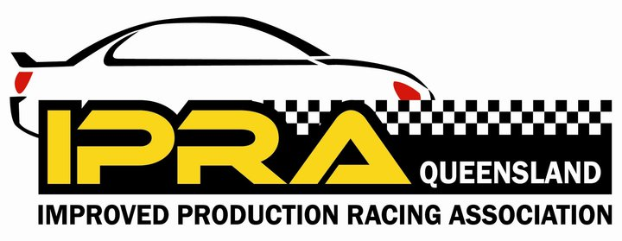
CODE OF CONDUCT

QUEENSLAND IMPROVED PRODUCTION RACING ASSOCIATION INC.

This Code of Conduct contains the Queensland Improved Production Racing Association Inc (QIPRA) guidelines and expectations concerning behaviour and conduct of our members representing QIPRA at any time or in any place including, without limitation:

•At QIPRA events such as social or general club events
•At all motoring events when representing QIPRA
•At all other times when engaged in any activity linked to QIPRA

Social Media

QIPRA recognises that many members choose to participate in social media of all forms, from time to time.

We respect the rights of members to use blogs and other social media tools (Emails, Facebook, Twitter, YouTube etc) not only as a form of self- expression, but also sometimes to conduct other activities.

It is important that all members are aware of the implications of engaging in forms of social media and online conversations that reference QIPRA or QIPRA members.

QIPRA’s expectations of member’s personal behaviour in social media

There is a big difference between speaking on behalf of QIPRA and speaking about
QIPRA.

The following principles refer to those personal or unofficial social media activities where you might refer to QIPRA or QIPRA members, be it during or outside of a race event.
Have fun, but be smart

Approach the social media world in the same way as we do the physical one – by sound judgment and after careful consideration of the ramifications of your intended comments, including the awareness of the possibility of the commission of offences under the Statute Laws of the state of Queensland.

The Personal Attack Rule

Abuse, insults and personal attacks directed at other members are unacceptable. There is no grey area in what is a personal attack - it is when a negative statement is directed towards another person.

If you disagree with someone on an issue, do not resort to name calling or personal attacks; rather argue the merits of the points for and against. There will be no tolerance of comments meant to offend or hurt QIPRA or any QIPRA member in a manner which is offensive or inflammatory. There will be no tolerance of racial, ethnic, gender based insults or any other personal discriminations.

You are responsible for your actions

Any action you take that can potentially have a deleterious affect on QIPRA and QIPRA members will ultimately be your responsibility. If you make any such statements be prepared to clarify your remarks, initially at Committee level, and perhaps at a Special General Meeting of your peers.

It is very important that when referring to QIPRA or QIPRA members in the social media you ensure that the content is accurate and not based on suspicion, scuttle-butt, innuendo or other half baked notions or ideas.

If you have reservations regarding the action you are about to take, or about comments you are about to make and whether they comply with this Code of Conduct…don’t do it.

All Members are required to act in accordance with the following:

Professionalism

Acknowledge that QIPRA carries on the activity of providing fair, safe and socially responsible motor racing activities, an activity which is, therefore, vulnerable if its media, public or professional image is tarnished in any way.

Act professionally and represent QIPRA in a professional manner at all times. Members must not publicly do or say (or omit to do or say) anything which is (or may be
construed as) detrimental, prejudicial, offensive or unfavourable to QIPRA or QIPRA
members (or persons or entities related to our members legally or professionally), or which might generate unfavourable or undesirable criticism of them or of any of their products, services or personnel.
Good Sportsmanship

Acknowledge that a part of QIPRA’s activities is involvement in the hazardous and highly visible activity of motor sport and we must ensure we behave towards others in a professional and sportsmanlike manner.

Honesty

Members must not behave in a manner that exhibits bias to, or commit any premeditated breach of, the laws, regulations or other governing guidelines as applies to motor sport and which are present to ensure safe and fair competition.

Consideration of QIPRA, Event Organisers and Key Stakeholders

All members must recognise the authority of, and comply with the rules, regulations, determinations, resolutions, directions or orders from time to time in force, of all organisations and professional bodies which control clubs or any other aspect of the club from time to time, in particular, but not limited to, safety and disciplinary matters.

Compliance to venue rules

Members must observe and comply with the terms and conditions of any lease, licence, entry ticket or other agreement in force for any venue used for any event and comply with any applicable rules or regulations affecting the use of the venue or any instructions including Stewards of the meeting instructions, or requests made by or on behalf of the owner, lessee or licensee of the venue.

Compliance to health, safety and other issues

All members shall comply with the applicable Occupational Safety & Health laws.

Respect of Intellectual property

Without limiting their obligations, members must not do (or omit to do) or be involved in the doing (or omission) of any act or thing by which intellectual property rights owned by QIPRA may be lost or detrimentally affected.

In addition, members shall not release such documents or other information acquired during their membership without the prior authorisation of the QIPRA Committee.

Alcohol and Drugs

Whilst representing QIPRA, or engaged in racing, members must not be under the influence of any deleterious substances.

QIPRA is bound by The Australian Auto-Sport Alliance (AASA) and The Confederation of Australian Motor Sport (CAMS) Anti-Doping Policies.

All policies are available on the Internet.

Alcohol consumption by members is controlled by relevant State and CAMS laws before, during or after events. Members shall ensure compliance with those rules.

Expulsion of Members

The constitution of QIPRA allows for disciplinary action, including expulsion of a member, to be applied for breaches of matters spelt out in this document.

Any such action will be carried out in line with the guidelines as laid out in the Constitution.

Questions and Policies

Any questions or clarifications sought with respect to this Code of Conduct shall be addressed with Committee.

Please ensure that you have read and agree to the Code of Conduct of QIPRA, as it will be a requirement for acceptance for membership and members will sign the relevant clause on the application form.

REMEMBER

A failure to adhere to QIPRA policies may result in disciplinary action that may range from a warning to termination of your membership.

This Code of Conduct, as amended from time to time, binds all members of QIPRA.

