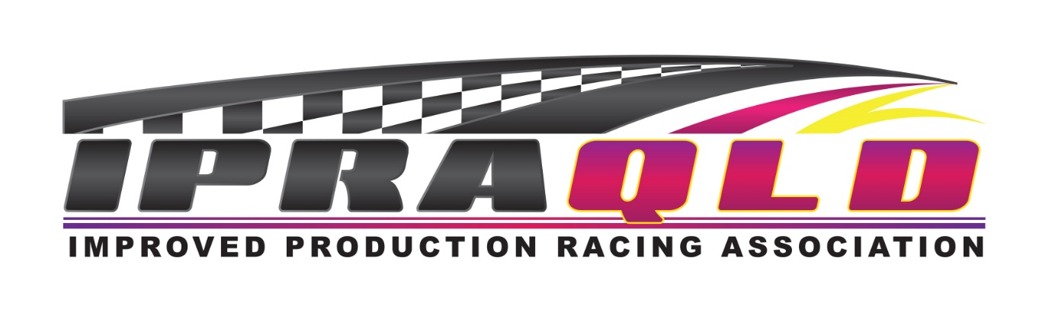

QIPRA RACE CALENDER 2021

Round 1: Morgan Park Raceway March 26/27/28

Round 2: Morgan Park Raceway June 04/05/06

Round 3: Morgan Park Raceway June 25/26/27

Round 4: Morgan Park Raceway August 27/28/29

IPRA NATIONALS Morgan Park Raceway October 01/02/03

Round 5: Morgan Park Raceway November 19/20/21

Please note some dates may be subject to change for any number of reasons.
Including any Covid 19 related outcomes
QIPRA members will be notified of any changes as soon as possible.

